HDBuddyPro
[Project Plan]
Version 1.0

By:
Revision History

Revision Number | Date | Primary Author(s) | Comments
1.0 | 04/10/2026 |  | First version

Table of Contents

Revision History.................................................................................................................................................1
Table of Contents ..............................................................................................................................................2
1 Introduction...............................................................................................................................................3
1.1 Project Overview ................................................................................................................................3
1.2 Project Description and Scope .........................................................................................................3
2 Project Organization ................................................................................................................................4
2.1 Team Structure ....................................................................................................................................4
2.2 Roles and Responsibilities .................................................................................................................4
2.3 Team Communication .......................................................................................................................5
3 Process Definition ....................................................................................................................................6
3.1 Lifecycle Model ...................................................................................................................................6
4 Schedule .....................................................................................................................................................7
4.1 Activity Dependencies and Schedule ...............................................................................................7
4.2 Work Breakdown Structure...............................................................................................................8
4.3 Work Packages ..................................................................................................................................9
4.4 Activity Dependencies .....................................................................................................................9
4.5 Work Package Details ......................................................................................................................10
5 Project Estimates ....................................................................................................................................14
5.1 Code Size Estimation using Function Points ...............................................................................14
5.1.1 Unadjusted Function Points ....................................................................................................14
5.1.2 Adjusted Function Points ........................................................................................................16
5.1.3 Lines of Code.............................................................................................................................17
5.2 Efforts, Duration and Team Size Estimation...............................................................................17
5.2.1 Distribution of Effort...............................................................................................................17
5.3 Cost Estimates...................................................................................................................................18
6 Product Checklist....................................................................................................................................19
7 Best Practice Checklist ...........................................................................................................................20
8 Risk Management....................................................................................................................................21
9 Quality Assurance ...................................................................................................................................22
10 Monitoring & Control ............................................................................................................................23
1 Introduction

1.1 Project Overview
Purchasing a home is a major milestone for Singaporean singles, newlyweds, and families, but the process can often feel overwhelming and confusing due to the housing information being scattered across multiple government sources. To address this, Team Kampong Crew developed HDBuddyPro, an intelligent web application designed to help users efficiently find their dream HDB resale flat that best matches their needs. The system curates helpful summaries of HDB flats and provides an intuitive, user-friendly platform that consolidates essential housing data.

1.2 Project Description and Scope
The HDBuddyPro web application integrates multiple core features to streamline the housing search process:
- Intuitive Filtering and Map Interface: Allow users to narrow HDB resale flats by region, price, room type, and remaining lease, visualising results on a interactive map using the OneMap API
- Curated Flat Summaries: Combining pricing and lease data with proximity metrics to schools, MRT stations and dengue clusters as well as real-time traffic camera status retrieved by data.gov.sg APIs.
- Personalized Ranking System: Employs adjustable weighted sliders for proximity to schools, MRT stations, dengue safety to rank available flats according to individual user priorities.
- AI-Powered Chatbot: Enables conversational, natural-language interactions for user to ask questions about flat prices, leases, and amenities
2 Project Organization

2.1 Team Structure
The following is the list of executive roles, as required by CMM level 3.
• Project Manager: Lim Wei Sheng
• Frontend Developer: Yun Kar Kit
• Backend Developer: Kee Yu Kai
• QA Manager: Loo Han Meng
• QA Engineer: Tai Yi Sheng Winston
• Release Manager: Lim Jun Jie

2.2 Roles and Responsibilities
Project Manager: Lim Wei Sheng
• Oversees project progress
• Approves and executes project plan
• Assigns tasks and reports status of project to team members
• Manages and motivates team members
• Represents the team to the outside world
Frontend Developer: Yun Kar Kit
• Collects information from client interviews
• Designs frontend from client requirements
• Develops frontend modules
Backend Developer: Kee Yu Kai
• Designs logical system based on requirements
• Translates logical design into detailed design
• Develops the backend modules
Quality Assurance Manager: Loo Han Meng
• Ensures acceptable software quality
• Designs testing strategies
• Creates and manages test plan
• Verify software requirements
• Executes test procedures
Quality Assurance Engineer: Tai Yi Sheng Winston
• Ensures acceptable software quality
• Designs testing strategies
• Creates and manages test plan
• Verify software requirements
• Executes test procedures
Release Manager: Lim Jun Jie
• Plans release cycle
• Measure and monitor progress
• Manage risks within project scope
2.3 Team Communication

Formal communication with the team will primarily be through telegram group chat, with weekly meetings to demonstrate progress, clarify requirements and record feedback, consistent with the proposal. Day-to-day collaboration will use GitHub issues and GitHub Projects to record tasks, assignments, status and deadlines. The team can hold further internal progress discussions and ad hoc technical sessions when dependencies or defects require attention.
- Decision tracking: major decisions and requirement changes are recorded in meeting notes and linked GitHub issues.
- Work tracking: a project board and the Gantt view are maintained
- Escalation: unresolved delivery risks and cross-functional blockers are raised to the Project Manager and discussed at the next team meeting or sooner if time-critical.

3 Process Definition
3.1 Lifecycle Model

The team intends to use the Agile Development Model throughout the project. This is tracked through Github Kanban, and it accommodates to progressive feature integration such as chatbot implementations. This allows for continuous refinement through regularly testing and feedback.
3.1 Lifecycle Model

The team intends to use the Agile Development Model throughout the project. This is tracked through Github Kanban, and it accommodates to progressive feature integration such as chatbot implementations. This allows for continuous refinement through regularly testing and feedback.

4 Schedule

4.1 Activity Dependencies and Schedule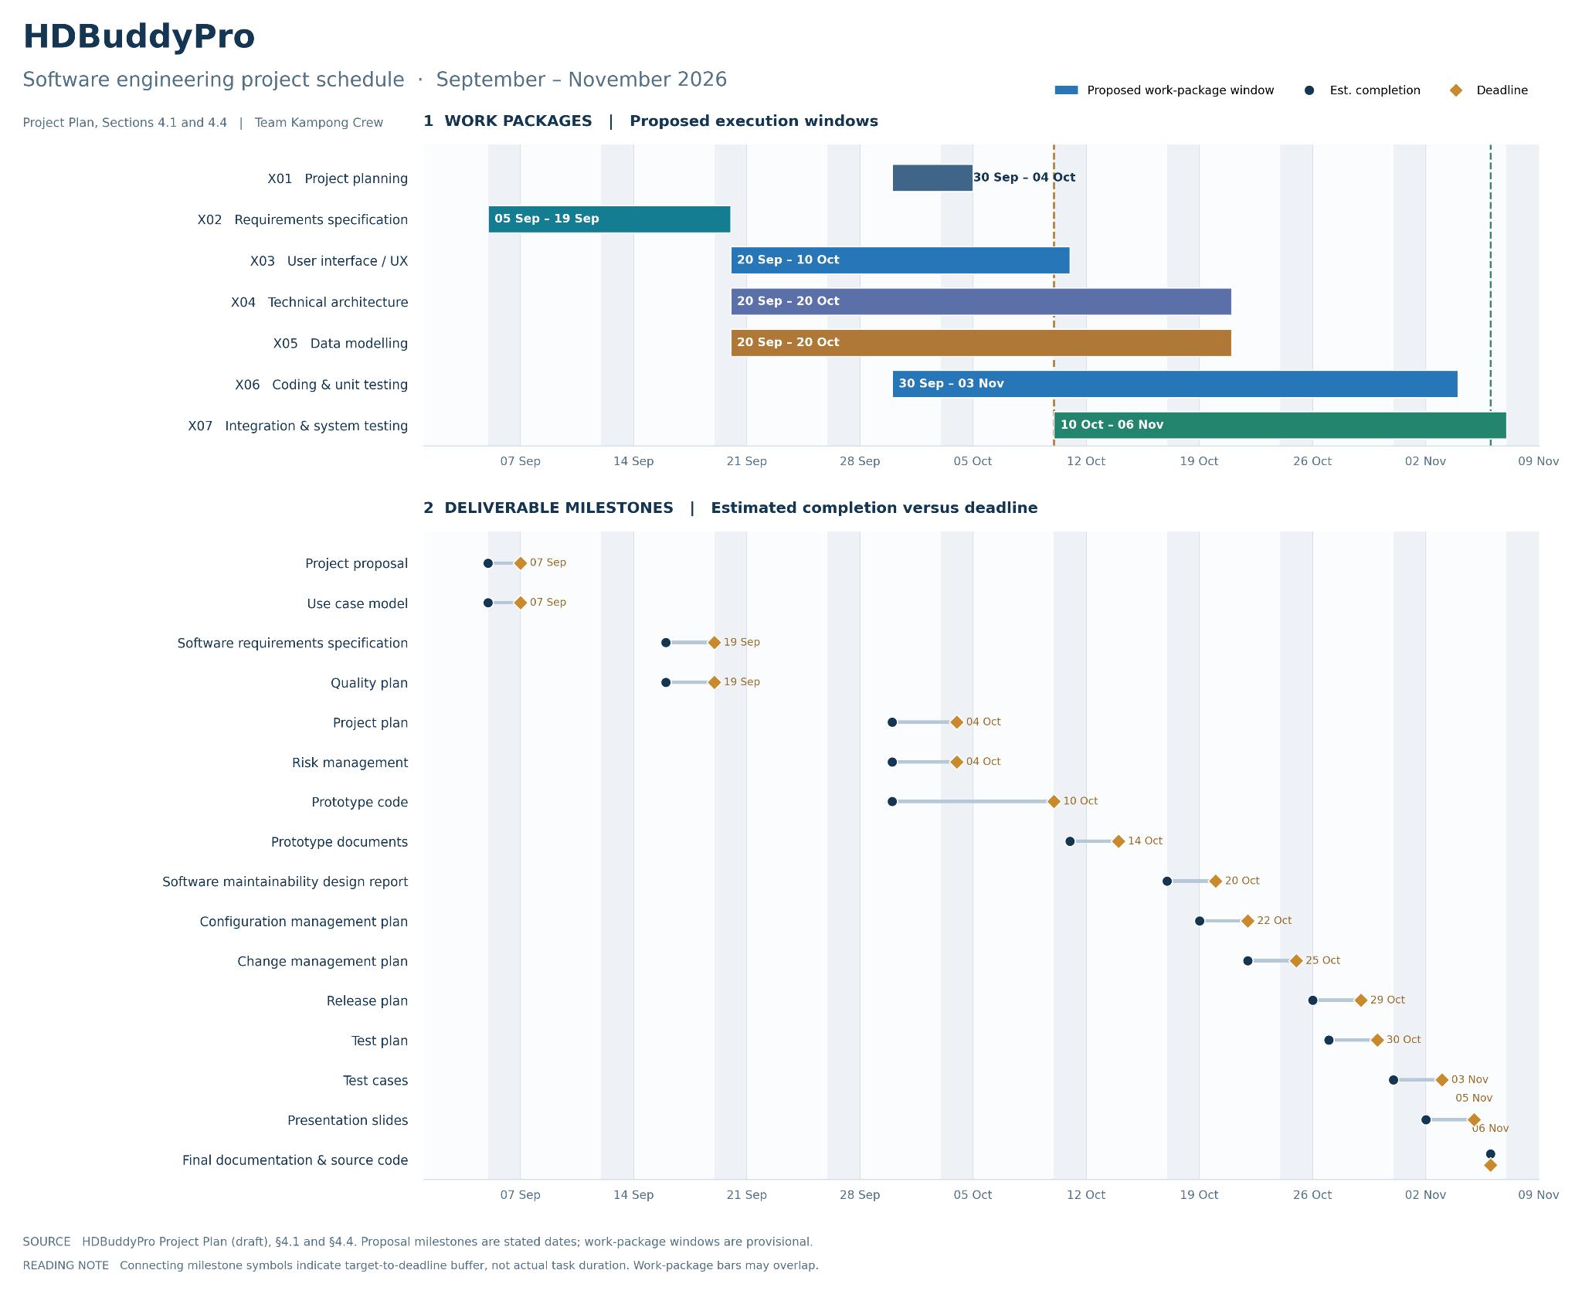

4.2 Work Breakdown Structure
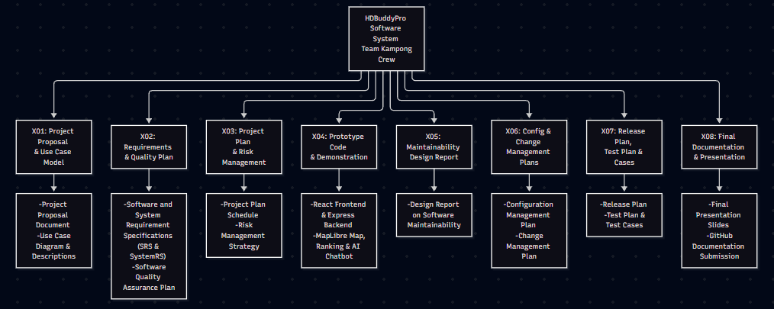

4.3 Work Packages
The entire project work is broken down by the important phases of the software
development life cycle. They include the following:

1. Project Plan
2. Requirement Specification
3. User Interface
4. Technical Architecture
5. Data Modeling
6. Coding & Unit Testing
7. Integration & Quality Assurance

4.4 Activity Dependencies
The following table describes the dependencies of the deliverable work packages:

Work  Package # | Work Package Description | Duration | Dependencies
X01 | Project Proposal & Use Case Model | 14 days | --
X02 | Software Requirement Specification & Quality Plan | 14 days | X01
X03 | Project Plan and Risk Management Document | 7 days | X02
X04 | Prototype Code & Presentation Material | 14 days | X03
X05 | Software Maintainability Design Report | 7 days | X04
X06 | Configuration & Change Management Plans | 7 days | X04, X05
X07 | Release Plan and Test Plan/Test Cases | 7 days | X04, X06
X08 | Final Documentation Submission | 7 days | X05, X06, X07

The following Activity Network Diagram describes the above in more graphical detail:

4.5 Work Package Details
Work packages are listed below. A team member, indicated in bold, has been assigned as primarily
responsible for each work package and will coordinate that package.

Project HDBuddyPro Software System

Work Package X01— Project Plan (1 of 7)

Assigned To Lim Wei Sheng, all remaining members

Effort 20 person-hours

Start Date 30 Sep 2026

Purpose To establish and maintain delivery scope, timeline, risks and a shared execution baseline.

Inputs Project proposal, team inputs

_{Activities} Review constraints and resources; structure project milestones and work packages; record dependencies; agree review and change procedures.
Outputs A written document of the Project Plan

Project HDBuddyPro Software System

Work Package X02— Requirement Specification (2 of 7)

Assigned To Lim Wei Sheng, all remaining members

Effort 30 person-hours

Start Date 05 Sep 2026

Purpose To define observable HDBuddyPro functional and quality requirements.

Inputs Project objectives, proposed use cases, available dataset and API considerations

_{Activities} Specify functionalities like filtering, search, chatbot and error conditions; review clarity and traceability.

Outputs Use Case Model, SRS, acceptance criteria.

Project HDBuddyPro Software System

Work Package X03— User Interface (3 of 7)

Assigned To Yun Kar Kit, all remaining members

Effort 10 person-hours

Start Date 20 Sep 2026

Purpose To build the user interface for HDBuddyPro

Inputs SRS baseline, data fields and API contracts

_{Activities} Implement React views, filtering and search functionalities, chatbot presentation.
.
Outputs Functional prototype UI.

Project HDBuddyPro Software System

Work Package X04— Technical Architecture (4 of 7)

Assigned To Kee Yu Kai, all remaining members

Effort 10 person-hours

Start Date 19 Sep 2026

Purpose To define high level architecture plan including application components, boundaries, dependencies and runtime choices.

Inputs SRS, proposed technical stack.

_{Activities} Design backend routes, services, error handling, module interfaces, deployment assumptions and maintainability mechanisms
Outputs High level architectural design and documentation and maintainability report.

Project HDBuddyPro Software System

Work Package X05— Data Modeling (5 of7)

Assigned To Kee Yu Kai, all remaining members

Effort 10 person-hours

Start Date 20 Sep 2026

Purpose To organise public housing, amenity, geolocation data

Inputs OneMap responses, data.gov.sg HDB records.

_{Activities} Analyze the data flow relationships and define the entity relationships

Outputs Documentation and verification of datasets used

Project HDBuddyPro Software System

Work Package X06— Coding & Unit testing (6 of 7)

Assigned To Yun Kar Kit, Kee Yu Kai, all remaining members

Effort 30 person-hours

Start Date 30 Sep 2026

Purpose To implement the HDBuddyPro system as per the requirements specification and other associated documents, specifically frontend and backend features alongside conducting unit tests.

Inputs SRS, UI design and system architecture documents.

_{Activities} Frontend and backend developers will implement the modules according to the design specifications from the SRS.

Outputs Source code, unit test result

Project HDBuddyPro Software System

Work Package X07— Integration & System Testing (7 of 7)

Assigned To Loh Han Meng, all remaining members

Effort 30 person-hours

Start Date 10 Oct 2026

Purpose To verify end-to-end behaviour, by identifying and fixing logical and syntactical errors produced during the implementation of the system. If any issues are discovered, they will be noted and fixed at the earliest possible time.

Inputs System prototype, test plan and acceptance criteria.

_{Activities} Test the workflows with edge cases and invalid inputs, record defects, implement fixes and re-test fixes, and then document results.
Outputs Test plan, test cases, results documentation.
5 Project Estimates

5.1 Code Size Estimation using Function Points
This section applies the supplied Project Plan template’s function-point, effort and cost-estimation method to HDBuddyPro, a Singapore HDB resale flat search web application. The function counts, complexity classifications, effort and code-size factors are provisional planning assumptions; the proposal does not establish measured function-point or development-hour data.

5.1.1 Unadjusted Function Points
HDBuddyPro’s proposed user-facing functions, taken from the project proposal, are:
- Search and filter HDB resale flats by region, budget/price, room type and remaining lease.
- Display matching flats on a map with summary cards showing address, lease, price and nearby amenities.
- Rank flats using adjustable weights for schools, MRT accessibility and dengue-cluster proximity.
- View regional resale-price distributions and flat-type frequencies, and revisit previously viewed flats.
- Ask natural-language questions about flats through an AI-powered chatbot.
The proposal does not specify administrator-facing reservation or customer-account features. Those airline-template functions are excluded. The following DET/FTR/RET counts are illustrative and require validation against the implemented interface, data model and integration boundaries.

Rating Inputs (EI)
FTR | 1–4 DET | 5–15 DET | >15 DET
0–1 | Low (3) | Low (3) | Average (4)
2 | Low (3) | Average (4) | High (6)
3 or more | Average (4) | High (6) | High (6)

HDBuddyPro external input | DET* | FTR* | Complexity (FP)
Enter / update flat search criteria | 6 | 2 | Average (4)
Set personalised ranking weights | 5 | 2 | Average (4)
Submit chatbot question | 2 | 1 | Low (3)

Rating Outputs (EO)
FTR | 1–5 DET | 6–19 DET | >19 DET
0–1 | Low (4) | Low (4) | Average (5)
2–3 | Low (4) | Average (5) | High (7)
4 or more | Average (5) | High (7) | High (7)

HDBuddyPro external output | DET* | FTR* | Complexity (FP)
Filtered flat results on interactive map | 12 | 4 | High (7)
Selected-flat summary card | 10 | 3 | Average (5)
Personalised ranked flat results | 8 | 4 | High (7)
Regional price and flat-type charts | 8 | 2 | Average (5)
Contextual AI chatbot response | 9 | 4 | High (7)

Rating Inquiries (EQ)
FTR | 1–5 DET | 6–19 DET | >19 DET
0–1 | Low (3) | Low (3) | Average (4)
2–3 | Low (3) | Average (4) | High (6)
4 or more | Average (4) | High (6) | High (6)

HDBuddyPro external inquiry | DET* | FTR* | Complexity (FP)
Retrieve previously viewed flat list | 4 | 1 | Low (3)
Look up uncalculated flat metadata | 8 | 2 | Average (4)

Rating Logical Files (ILF)
RET | 1–19 DET | 20–50 DET | 51+ DET
1 | Low (7) | Low (7) | Average (10)
2–5 | Low (7) | Average (10) | High (15)
6 or more | Average (10) | High (15) | High (15)

HDBuddyPro internal logical file | DET* | RET* | Complexity (FP)
Processed resale-flat records (MongoDB) | 24 | 2 | Average (10)
Processed amenity/geospatial records | 25 | 3 | Average (10)
Recently viewed flat state (if server-managed) | 8 | 1 | Low (7)

Rating Interfaces (EIF)
RET | 1–19 DET | 20–50 DET | 51+ DET
1 | Low (5) | Low (5) | Average (7)
2–5 | Low (5) | Average (7) | High (10)
6 or more | Average (7) | High (10) | High (10)

External referenced data (candidate EIF) | DET* | RET* | Complexity (FP)
data.gov.sg HDB resale records | 25 | 2 | Average (7)
OneMap address/geocoding reference data | 21 | 2 | Average (7)
Public dengue-cluster dataset | 15 | 1 | Low (5)

Estimation note. *DET, FTR and RET values are illustrative assumptions, not measured data counts. ILFs must be data groups maintained by HDBuddyPro; EIFs must be externally maintained groups referenced across its boundary. A dataset imported into the local database may need a different classification. A map API call alone is not automatically an EIF. Recently viewed state is an ILF only if managed by the application’s backend. Avoid double-counting overlapping inquiries and computed outputs.

Summary of Function Point Classification
Functional type | Low | Average | High | FP subtotal
External Inputs (EI) | 1 × 3 = 3 | 2 × 4 = 8 | 0 × 6 = 0 | 11
External Outputs (EO) | 0 × 4 = 0 | 2 × 5 = 10 | 3 × 7 = 21 | 31
External Inquiries (EQ) | 1 × 3 = 3 | 1 × 4 = 4 | 0 × 6 = 0 | 7
Internal Logical Files (ILF) | 1 × 7 = 7 | 2 × 10 = 20 | 0 × 15 = 0 | 27
External Interface Files (EIF) | 1 × 5 = 5 | 2 × 7 = 14 | 0 × 10 = 0 | 19
TOTAL UNADJUSTED FUNCTION POINTS |  |  |  | 95

Unadjusted Function Points (UFP) = 11 + 31 + 7 + 27 + 19 = 95.

5.1.2 Adjusted Function Points
Following the template, each of the fourteen General System Characteristics (GSCs) is provisionally scored from 0 (no influence) to 5 (strong influence). The Value Adjustment Factor (VAF) is calculated as 0.65 + 0.01 × Total Degree of Influence (TDI).
General system characteristic | Score | HDBuddyPro planning rationale
Data communications | 4 | Browser-to-backend calls and government/mapping API access.
Distributed processing | 4 | Frontend, Node.js backend, datastore and external services.
Performance | 3 | Responsive map searches and ranking calculations matter.
Heavily used configuration | 2 | Moderate expected browser and device variation.
Transaction rate | 2 | Interactive traffic anticipated; no measured peak load.
Online data entry | 3 | Users supply filters, weights and questions.
End-user efficiency | 5 | Usability of filters, map and tutorial is a core objective.
Online update | 2 | Potentially refreshed housing and amenity data.
Complex processing | 4 | Weighted ranking, proximity calculations and chatbot.
Reusability | 3 | Reusable React components and backend services.
Installation ease | 2 | Typical web build, API configuration and deployment.
Operational ease | 3 | Automated ingestion and predictable API error handling desirable.
Multiple sites | 3 | Browser-based access from multiple end-user locations.
Facilitate change | 4 | Filters, weights, data sources and UI may evolve.
TOTAL DEGREE OF INFLUENCE | 44 | Provisional, to be confirmed by the team.

Influence Multiplier (VAF) = 0.65 + (0.01 × 44) = 1.09.
Adjusted Function Points (AFP) = UFP × VAF = 95 × 1.09 = 103.55 FP.

5.1.3 Lines of Code
The reference template uses a historical C++ conversion factor of 29 lines of code (LOC) per function point. HDBuddyPro uses React/Vite and a Node.js/Express backend, so this C++ factor should not be copied to the project without adjustment. For illustration only, assume 50 manually written LOC per adjusted FP for the JavaScript application.
Estimated LOC = 103.55 AFP × 50 LOC/FP = 5,177.5 ≈ 5,178 LOC.

5.2 Efforts, Duration and Team Size Estimation
The proposal lists six project members and deliverables from early September to 6 November 2026. As it does not specify planned person-hours or productivity data, the following team-capacity model is used in place of the template’s historical C++ productivity rate. It aligns with the proposal’s dated delivery window and the earlier draft’s provisional 540-hour estimate.
Planning parameter | Value | Calculation / assumption
Team size | 6 persons | Six named Kampong Crew members in the proposal.
Project window | 7 Sep–6 Nov 2026 | Nine consecutive calendar weeks; 45 Monday–Friday workdays.
Available time per person | 10 hours/week | Illustrative part-time university project allocation.
Base development effort | 540 person-hours | 6 members × 9 weeks × 10 hours/week.
Person-days (PD) | 67.5 PD | 540 person-hours ÷ 8 hours per person-day.
Average daily full-time equivalent | 1.5 FTE | 67.5 person-days ÷ 45 weekdays.
Equivalent utilisation per member | 0.25 FTE | 10 weekly hours ÷ 40 nominal full-time hours.

The schedule duration is nine calendar weeks, not 67.5 calendar days: work is shared and overlapping. The six-person headcount is known from the proposal; the effort and utilisation are scenario assumptions. The template’s cubic duration equation and historical LOC-per-person-day productivity are not applied because they have not been calibrated for this team.
5.2.1 Distribution of Effort
The provisional 540 person-hours are apportioned to the seven work packages used in the project plan. These values measure aggregate person-hours, not elapsed calendar durations.
Work package | Effort (PH) | Effort (PD) | Share
X01 — Project Plan | 50 | 6.25 | 9.3%
X02 — Requirement Specification | 60 | 7.50 | 11.1%
X03 — User Interface | 80 | 10.00 | 14.8%
X04 — Technical Architecture | 65 | 8.125 | 12.0%
X05 — Data Modeling | 65 | 8.125 | 12.0%
X06 — Coding & Unit Testing | 120 | 15.00 | 22.2%
X07 — Integration & Quality Assurance | 100 | 12.50 | 18.5%
BASE EFFORT | 540 | 67.50 | 100%

Additional allowance | Rate on base | Extra hours | Revised effort
Project management allowance | 2% | 10.8 | 550.8 PH
Contingency reserve | 3% | 16.2 | 567.0 PH total
TOTAL including both allowances | 5% | 27.0 | 567.0 PH (70.875 PD)

Following the template, an optional 2% project-management allowance and 3% contingency reserve increase the 540 PH base estimate to 567 PH. If these allowances are treated as additional work, the assumed 540 PH team capacity has a 27 PH shortfall. The team must either increase its allocation to 10.5 hours per member per week, rebalance effort, or count some of the X01 management work within the allowance to prevent double-counting.

5.3 Cost Estimates
The HDBuddyPro project proposal (Budget, page 12 of the supplied PDF) provides the following amounts. They are reproduced without replacing them with the airline example’s hardware/software costs. The proposal uses “$” without explicitly defining its currency code; all figures below therefore retain that notation.

Staff Resources
Resource | Quantity | Unit cost | Subtotal
Project Manager | 1 | $8,000.00 | $8,000.00
Frontend Developer | 1 | $5,000.00 | $5,000.00
Backend Developer | 1 | $5,500.00 | $5,500.00
QA Manager | 1 | $6,000.00 | $6,000.00
QA Engineer | 1 | $4,500.00 | $4,500.00
Release Manager | 1 | $5,000.00 | $5,000.00
TOTAL STAFF | 6 |  | $34,000.00

Hardware and Services
Item | Quantity | Unit cost | Subtotal
Dell laptop | 6 | $1,500.00 | $9,000.00
AI API (labelled per month in proposal) | 5 | $100.00 | $500.00
TOTAL HARDWARE AND SERVICES |  |  | $9,500.00

Budget component | Amount
Staff | $34,000.00
Hardware | $9,000.00
AI API provision | $500.00
TOTAL PROPOSAL BUDGET | $43,500.00

Estimation note. The proposal calls its budget a monthly breakdown but includes one-off laptop purchases and an “AI API (per month)” line with quantity five. Thus $43,500 is the sum of listed budget items, not a verified nine-week total cost or approved cash expenditure. Staff-cost periods, API billing duration, hosting, other paid services and taxes require confirmation; no additional amounts have been invented.
6 Product Checklist

The plan is that the items listed below will be delivered on the stated deadlines.

Project Deliverable | Estimated Deadline
Project Proposal & Use Case Model | Sep 9th , 2026
Software Requirement Specification & Quality Plan | Sep 19th, 2026
Project Plan and Risk Management Document | Oct 4th , 2026
Prototype Code & Presentation Material | Oct 14th, 2026
Software Maintainability Design Report | Oct 20th, 2026
Configuration & Change Management Plans | Oct 26th, 2026
Release Plan and Test Plan/Test Cases | Nov 3rd, 2026
Final Documentation Submission | Nov 10th, 2026

7 Best Practice Checklist

Practice | 9
Document what we do; all documentation must be in a standardized format.
Pay attention to requirements, check for ambiguity, completeness, accuracy, and consistency. The requirement documentation must contain a complete functional specification.
Keep it simple. Complexity management is one of the major challenges. Strive to:
• Minimize interfaces between modules, procedures and data.
• Minimize interfaces between people, otherwise exponential communication cost
• Avoid fancy product functions, design as long as the functionality meets the customer requirements
Require Visibility. We must see what we build otherwise we can measure the progress and take management action. This includes: the manager must have good communication with his or her employees; require developers to make code available for review; review design for appropriateness.
Plan for continuous change. We must:
• All manuals designs, test, source code should have revision numbers and dates revision history comments, change marks to indicate the changes
• New revisions should e approved before being made and checked for quality and compliance after being made
• Use a configuration management system and make processes
• Required maintenance
Don’t under estimate. We must be careful to obtain accurate estimates for: time, effort, overhead, meeting time, and especially effort on integration, testing, documentation and maintenance.
Code reviews are a much more efficient method to find software defects. Plan and manage code reviews between team members
Software testing will use both black box and white box testing. It will involve unit, functional, integrating and acceptance testing.

8 Risk Management
Besides the general risk management procedures outlined in the Risk Management Plan, the following key risks have been identified for the HDBuddyPro project:

R01 – External API Unavailability
Impact Severity: High
Probability: Medium (30–70%)
Impacts: Unavailability of external services such as Data.gov.sg or OneMap may disrupt the retrieval of HDB resale information, geolocation data and interactive map functionalities. Users may be unable to access updated housing information or view flats on the map.
Risk Reduction: Implement API error handling, monitor API availability and validate API responses during integration testing. Where permitted, previously validated cached data may be used as a contingency, with appropriate data freshness indicators.

R02 – Inaccurate or Outdated Housing Information
Impact Severity: High
Probability: Medium (30–70%)
Impacts: Incomplete, inconsistent or outdated government datasets may result in inaccurate resale prices, remaining lease information or surrounding amenity details being displayed. This could mislead users when comparing HDB flats and reduce their confidence in the application.
Risk Reduction: Validate retrieved datasets, monitor updates from government data sources and implement appropriate data consistency checks. Display data freshness information and indicate when information is unavailable or cannot be verified.

R03 – Frontend and Backend Integration Failures
Impact Severity: High
Probability: Medium (30–70%)
Impacts: Integration difficulties between the React frontend, Express.js backend, MongoDB database and supporting data services may prevent essential application functionalities from operating correctly. Additional debugging and rework may delay development and testing activities.
Risk Reduction: Establish clear API contracts between system components, conduct integration testing early and maintain communication between frontend and backend developers.

R04 – Development Schedule Delays
Impact Severity: High
Probability: Medium (30–70%)
Impacts: Underestimated development effort, unforeseen technical difficulties or delays in completing dependent tasks may affect project milestones. This could reduce the time available for system integration, testing and release preparation.
Risk Reduction: Monitor development progress through the GitHub Kanban board, review task estimates regularly and prioritise activities on the project's critical path. Redistribute tasks or adjust lower-priority activities where necessary.

R05 – Inaccurate AI Chatbot Responses
Impact Severity: High
Probability: Medium (30–70%)
Impacts: The AI-powered chatbot may generate incorrect, misleading or unsupported housing-related information. This could affect users' understanding of resale flat attributes, pricing or nearby amenities and reduce trust in the application.
Risk Reduction: Validate chatbot responses against available housing information, constrain responses to supported data and communicate limitations clearly. Direct users to verified information or temporarily disable affected chatbot functionality when necessary.

R06 – Release of Incorrect Personalised Ranking Results
Impact Severity: Medium
Probability: Medium (30–70%)
Impacts: Errors in ranking calculations or the application of user-defined weights may cause flats to be ranked incorrectly, preventing users from identifying properties that best match their preferences.
Risk Reduction: Establish and validate ranking calculation rules using predefined test cases and expected outputs. Avoid releasing the personalised ranking feature if critical ranking tests fail. As a contingency, temporarily disable the ranking feature while retaining standard flat filtering functionality.

R07 – Limited Team Availability
Impact Severity: Medium
Probability: Medium (30–70%)
Impacts: Unexpected team member absences or limited resource availability may delay assigned tasks, increase the workload of remaining members and affect the completion of project deliverables. The temporary loss of specialised knowledge may also slow development.
Risk Reduction: Accept and monitor the possibility of unexpected team member unavailability. Maintain visibility over resource availability and redistribute critical tasks among available team members if necessary, adjusting task priorities to minimise schedule disruption.
R08 – Insufficient Testing Time
Impact Severity: Medium
Probability: Medium (30–70%)
Impacts: Development or integration delays may reduce the time available for system, integration and acceptance testing. Software defects may remain undetected, potentially affecting the quality and reliability of the final application.
Risk Reduction: Begin testing activities early, prioritise test cases covering essential functionalities and monitor testing progress against the project schedule.

R09 – Application Performance Issues
Impact Severity: Medium
Probability: Medium (30–70%)
Impacts: Processing large housing datasets, rendering numerous map markers or performing inefficient database queries may increase application response times. Slow filtering, map navigation or ranking calculations could negatively affect user experience.
Risk Reduction: Optimise database queries and data processing operations, minimise unnecessary rendering and conduct performance testing using representative datasets.

R10 – Unexpected AI API or Hosting Costs
Impact Severity: Medium
Probability: Low (below 30%)
Impacts: Higher-than-anticipated API usage or hosting requirements may cause project expenses to exceed the estimated budget. Additional costs could restrict the availability of AI chatbot functionality or other externally hosted services.
Risk Reduction: Monitor API consumption and hosting expenditure, implement appropriate usage limits and periodically review resource requirements. Adjust non-critical service usage or hosting arrangements if costs exceed the available budget.

9 Quality Assurance
To ensure that HDBuddyPro meets the expected requirements and provides a good user experience, the team will follow the quality assurance practices outlined in the Quality Plan. Regular reviews and testing will be carried out throughout development to identify and resolve issues early.
The team will mainly use two testing approaches:
- Unit Testing: Individual features, such as the flat filtering system, ranking algorithm, and data retrieval functions, will be tested separately to ensure they work as intended.
- Integration and System Testing: Different components will be tested together to ensure that the frontend, backend, and external APIs work properly as a complete system.
Testing will focus on two main aspects of HDBuddyPro:
- System Functionality: Ensuring that features such as searching for HDB flats, displaying information on the map, filtering results, and interacting with the chatbot work correctly.
- Algorithmic Functionality: Checking that the personalised ranking system produces appropriate results based on the user's selected preferences, such as proximity to MRT stations, schools, and dengue safety.
The team will also test the application using realistic scenarios, such as users searching for flats within a specific budget or adjusting their preferences to find suitable housing options. Edge cases, such as missing data, unavailable API responses, or searches with no matching flats, will also be considered to ensure the system handles these situations appropriately.
Any bugs or issues discovered during testing will be documented and tracked using GitHub Issues. The development team will address these problems, and the affected features will be tested again to confirm that the fixes work correctly. Testing results and feedback will be reviewed regularly to help improve the overall reliability and usability of HDBuddyPro.

10 Monitoring & Control
To ensure that HDBuddyPro stays on track, the team will regularly monitor project progress and compare it against the planned schedule. This helps us identify potential delays, resolve issues early, and make adjustments when necessary.
Quantitative Measurement of Resource Consumption
The team will track the time and effort spent on development tasks and compare them with the initial estimates in the Project Plan. GitHub Issues and GitHub Projects will be used to monitor task assignments, progress, and completion status. This allows the Project Manager to identify tasks that are taking longer than expected and redistribute work when necessary to keep the project on schedule.
Identification of Major Project Risks
Potential risks will be monitored throughout the development process to minimise their impact on the project. For HDBuddyPro, these include issues such as external API failures, inaccurate or outdated data, difficulties integrating different system components, and unexpected development delays.
The team will refer to the Risk Management Plan to assess these risks and decide on suitable actions. Any new risks identified during development will also be discussed and documented so that the team can address them before they become more serious.
Regular Reviews of Project Progress
The team will hold weekly meetings to review completed tasks, discuss ongoing work, and identify any problems faced during development. Telegram will be used for day-to-day communication, while GitHub will be used to track development progress and manage tasks.
During these meetings, members will provide updates on their assigned tasks and raise any issues that require attention. Important discussions, decisions, and follow-up actions will be recorded in the meeting minutes to ensure that everyone is aware of their responsibilities.
Timeline Planning and Task Decomposition
The project will be broken down into smaller tasks based on the Work Breakdown Structure (WBS) in Section 4. Each task will have an assigned team member, estimated completion time, and expected outcome.
The team will regularly review the project timeline to check whether tasks are progressing as planned. If delays occur, we will discuss possible solutions, such as adjusting task priorities, redistributing work, or revising the schedule. This helps ensure that development remains manageable and that important milestones are completed on time.

